Practical 26:

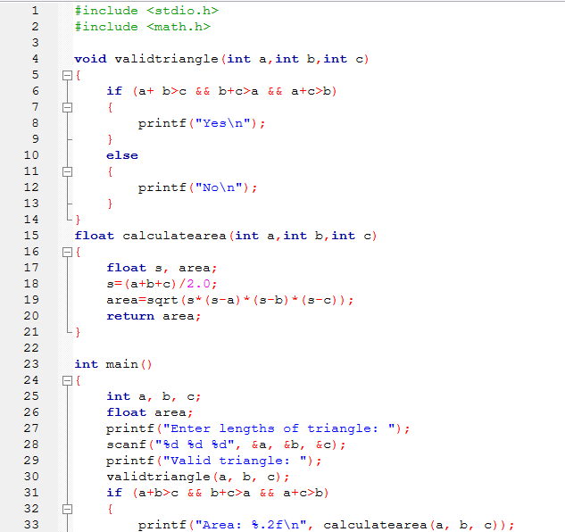

26-I,ii:

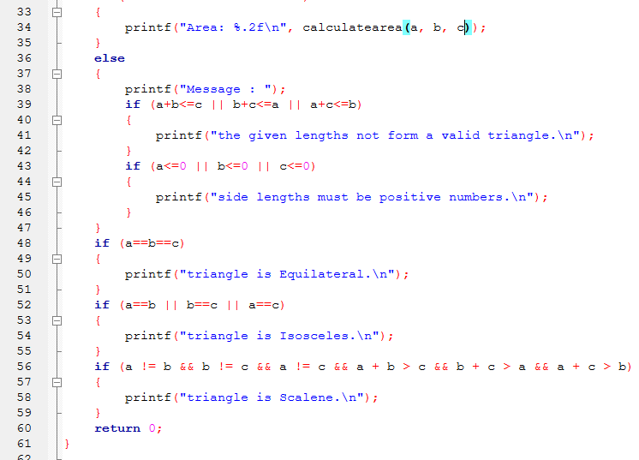

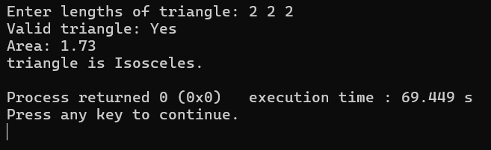

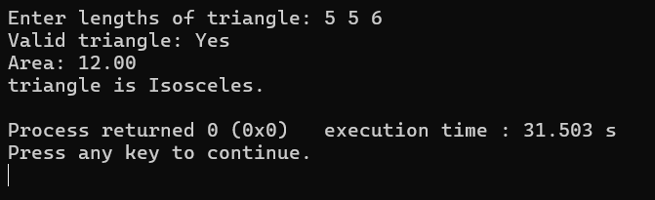

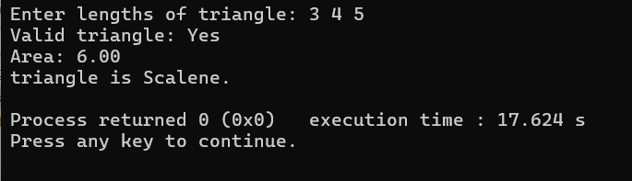

26-iii:

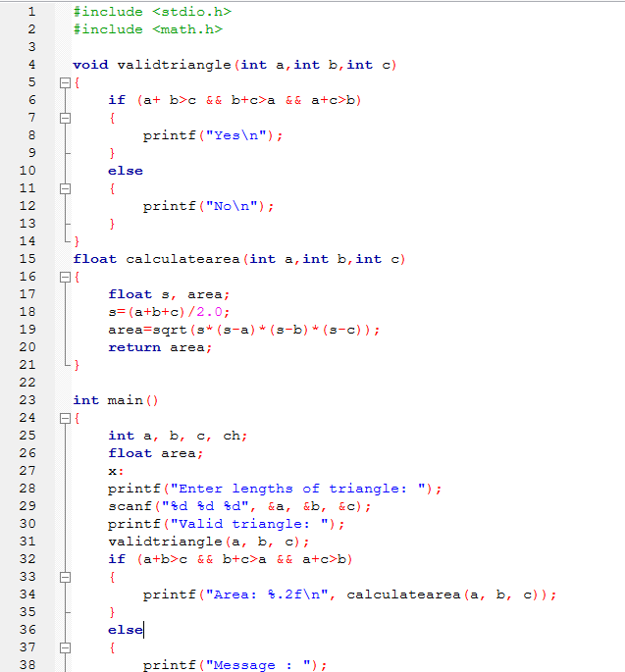

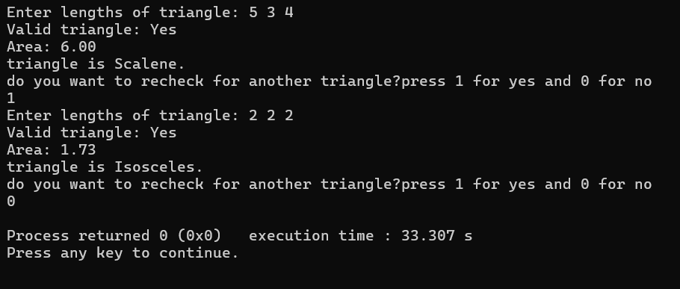

26-iv:

